Name -----------------------------------------Muhammad Talha
Reg_No----------------------------------------UW-24-BS-CS-101
Section----------------------------------------------------CS 2nd – B
LAB 5
Tables
- Books
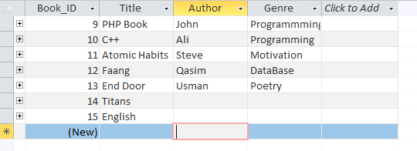

- Members
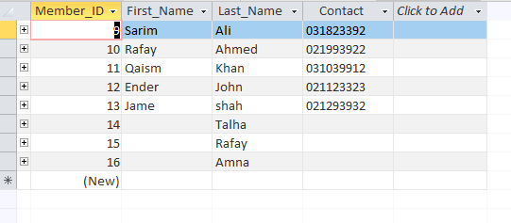

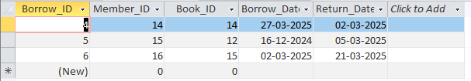
- BorrowedBooks:

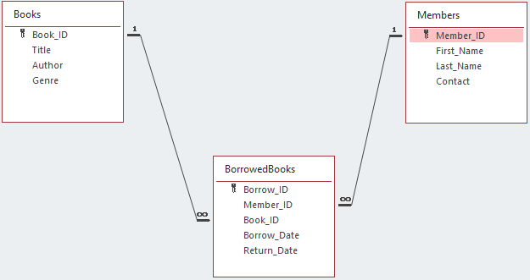
- Relation:
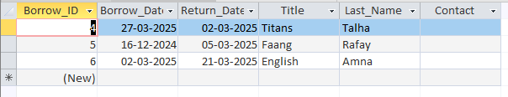
- Query:

